Social Security Disability and the Affordable Care Act

Background

The Patient Protection and Affordable Care Act (ACA) was signed into law by President Barack Obama on March 23, 2010 with the intent of improving access and affordability of health insurance within the United States. Through a number of employer and individual mandates, tax credits, subsidies for lower income Americans, and the creation of regulated health insurance marketplaces, the ACA aimed to expand coverage and control the rate of increase of health care costs nationwide.

Among other provisions, the ACA created health insurance exchange markets where individuals could purchase private health insurance without exclusions for pre-existing conditions. Participation in these exchanges by health insurers varies by State, and in certain States the exchange itself is State-run rather than using the Federal heathcare.gov platform. In addition, the ACA contained a provision for the expansion of Medicaid eligibility to individuals earning up to 128% of the Federal Poverty Line. This expansion, while intended to be mandatory for all States, was made optional by a later Supreme Court decision. Nineteen States did not adopt the expansion. Thus, the precise implementation of the ACA varies by State.

The ACA was an incremental reform that leveraged existing regulatory structures and programs to expand coverage. As such, the Congressional Budget Office’s (CBO) task in estimating the interacting budgetary effects of the reform needed to take into account the how both covered and uncovered individuals would move between non-coverage, employer provided coverage, existing individual policies, the new health insurance marketplaces, Medicaid and other government programs. Given this complex problem, the CBOs initial estimates must be continually re-evaluated based on its observed results as the program matures and changes. While most ACA provisions went into effect in 2014 or prior, there are provisions that are in flux through 2020 under current law and changes to the law are, of course, possible at any time.

Problem

One potential effect that went un-estimated by the CBO was movements within the Social Security Disability program. While the program is focused on income rather than health insurance, there is a provision that provides for Medicaid eligibility after one year of being enrolled in the disability program (or Medicare eligibility after two years, depending on which program(s) the enrollee is eligible for). With this provision in place, prior to the ACA, the disability program was a viable way in which for individuals to eventually acquire health insurance coverage that was otherwise not available, even though that is not the primary goal of the program. Given that the ACA marketplaces provide an alternative means to acquire health insurance to all Americans, it could be the case that the ACA would reduce enrollments in the program and save the U.S. Government money on the Social Security side of the ledger. However, it is also possible that people who would otherwise go on disability are holding on to jobs that provide health insurance, and will go on disability now that they have access to health insurance independent of being employed. As CBO Senior Analyst Joyce Manchester testified to the House Ways and Means Committee (Manchester, 2013):

*Looking ahead, the Affordable Care Act is likely to influence application rates for the DI [disability insurance] program, but whether it will result in more or fewer beneficiaries is difficult to predict. Among other changes, that legislation will make it easier for people who have health problems to buy their own insurance; it will also provide new subsidies for individually purchased coverage and expand eligibility for Medicaid in states that choose to do so. On the one hand, people who do not have employment-based health insurance will find it easier to obtain subsidized coverage as well as to gain access to health care without applying for DI benefits. That change will tend to reduce applications to the DI program. On the other hand, some people who would lose employment-based health coverage if they left their jobs to apply for DI benefits will have access to insurance during the two-year waiting period for Medicare benefits, with no exclusions for preexisting conditions, through the health insurance exchanges that will be established under the law. Moreover, that insurance might be subsidized, depending on an individual’s income. Those considerations will tend to increase applications to the DI program.*

This project will investigate whether or not the ACA has measurably reduced or increased enrollment in Social Security Disability in the early implementation of the law. If the ACA did influence enrollments in the disability program, that would indicate that as the CBO makes its ongoing budget estimates for the ACA, it should take into account the costs or savings as a result of these effects.

Data

Data was obtained through numerous, mostly US Government, sources in the course of this project. Links to the data sources are provided in a bibliography, and the project folder in github contains the actual files used/generated for this project. The data was assembled from numerous source files into a dataframe containing time series from 2006-15 for each State as well as a national series:

* For ACA Enrollment data, I used the annual (final) enrollment reports published by the US Department of Health and Human Services. This data had to be extracted from internal tables in the pdf documents to plain text, then read into pandas frames and cleaned up via python code.
* For Economic Data (GDP, Personal Income, Employment, Compensation, Wages), I used the US Department of Commerce, Bureau of Economic Analysis to obtain series by State and Nationally
* For Demographic Data (Age of Population, Poverty Rates) and necessary reference data (State/Region mapping and State Name/State Code), I used data from the US Census Bureau.
* For Data on the Medicaid Expansion (a simple table of which States did and did not implement the expansion), I found structured data on the Kaiser Family Foundation website.

Data Exploration

Nationally, enrollments in the disability program have risen over time, both in levels and per capital terms. Figures 1 and 2 illustrate the growth in program utilization.

|  |  |
| --- | --- |
| Figure 1 | Figure 2 |

In both plots, there is a distinct reduction in the growth rate (and, in per capita terms a visible reduction) in enrollments corresponding with the timeframe of interest (2013-2015). However, the plots also appear to show an acceleration in disability enrollments beginning in around 2008. This corresponds with the major recession/depression resulting from the financial crisis. It is possible that at least some of the correction to trend disability enrollment growth is simply related to the overall economic recovery of the last few years. This can be seen most clearly in Figure 2, which plots the series from 2006-2015 only.

Disaggregated to the State level, the picture is somewhat messier. Figures 3-6 plot the percent change in per capita disability recipients by State, separated by Census region for simplicity of display. There seems to be more variability between States earlier in the series, with a compression later in the series but no picture emerges that is not simply consistent with the overall economic recovery. Adjustment for economic conditions is required.

|  |  |
| --- | --- |
| Figure 3 | Figure 4 |
| Figure 5 | Figure 6 |

Data for Modeling

In order to account for changes in economic conditions, several annual data series related to GDP, Employment and personal income were obtained and built into a pandas dataframe. In addition, datapoints related to population age and poverty rates were obtained from a separate source and added to the dataframe. These datapoints are maintained in the frame in terms of levels and percentage changes, and where appropriate adjusted for state/national population levels. The datapoints are:

* SSI Beneficiaries Per Capita (dependent variable in our model)
* Wages Per Capita
* Compensation Per Capita
* Compensation Per Job
* Employment to Population Ratio
* GDP Per Capita
* Personal Income Per Capita
* Average Age of Population
* Poverty Rate

The correlation matrix in Figure 7 was produced in R (GGally/ggpairs) rather than python (matplotlib) due to some useful extra built-in features included in the redundant cells of the table. It is clear (and expected) that many of our economic indicators are highly correlated with each other and will likely not be included in our final model due to the inefficiency caused by multicollinearity. Each datapoint was chosen from the available Bureau of Economic Analysis data due to it being plausibly related to disability enrollments (which are known to depend on overall economic conditions).

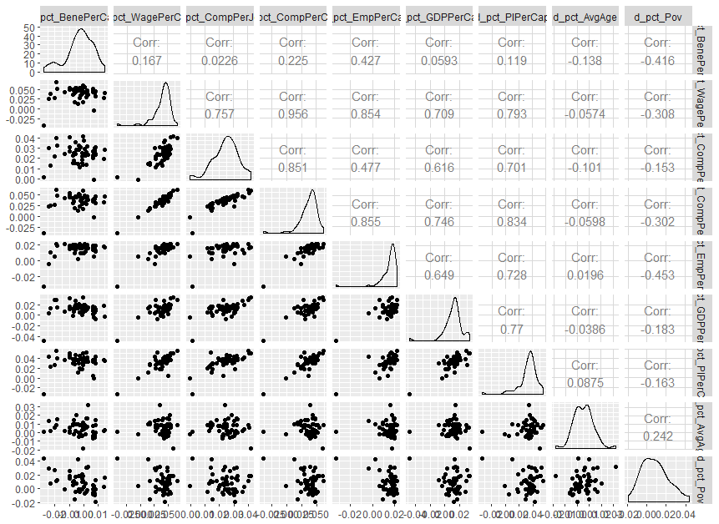

Figure

Testing for Structural Break

As a first attempt to establish an “ACA effect” on disability enrollments, we will use a Chow test to determine where structural breaks in the disability enrollments may occur. If there is a structural break corresponding to ACA implementation, it provides some evidence that the ACA has changed disability enrollments, when controlling for economic and demographic factors as in the previous section.

TBD

Prediction Using Enrollment Data

Two additional datapoints are available for a single year within the panel: State by State enrollments in the ACA Exchanges, and a dummy variable indicating a particular State expanded Medicaid in 2014. In this section, we will attempt to use these additional data elements to predict a given State’s change in disability enrollments on the basis of ACA utilization and overall economic conditions.

TBD

Non-linear Prediction Model

As an alternative specification, and to exercise some of the concepts from the course not applicable to panel OLS (such as hyperparameter selection via k-fold validation), we will attempt a non-linear prediction model using Kernel Ridge Regression

TBD

Conclusion

TBD

# References

Manchester, J. (2013). Testimony: The Social Security Disability Insurance Program. *House Ways and Means Committee.* https://waysandmeans.house.gov/UploadedFiles/Manchester_Testimony.pdf

**Data Sources:**

Medicaid Expansion by State (Kaiser Family Foundation): <http://www.kff.org/health-reform/state-indicator/state-activity-around-expanding-medicaid-under-the-affordable-care-act/?currentTimeframe=0&sortModel=%7B%22colId%22:%22Location%22,%22sort%22:%22asc%22%7D>

Mean Age by State, Poverty Rates (US Dept of Commerce, Census Bureau): <https://www.census.gov/cps/data/cpstablecreator.html>

Census Regions and Divisions (Census): <https://www2.census.gov/programs-surveys/popest/geographies/2011/state-geocodes-v2011.xls>

Per Capita GDP (US Dept of Commerce, Bureau of Economic Analysis): <https://www.bea.gov/itable/iTable.cfm?ReqID=70&step=1#reqid=70&step=10&isuri=1&7003=1000&7035=-1&7004=naics&7005=1&7006=xx&7036=-1&7001=11000&7002=1&7090=70&7007=-1&7093=levels>

Per Capital Personal Income (BEA): <https://www.bea.gov/itable/iTable.cfm?ReqID=70&step=1#reqid=70&step=30&isuri=1&7003=1000&7035=-1&7004=naics&7022=21&7005=1&7023=0&7033=-1&7024=non-industry&7006=xx&7025=0&7026=xx&7027=-1&7036=-1&7001=421&7028=-1&7002=1&7031=0&7040=-1&7083=levels&7029=21&7090=70&7093=levels&7007=-1>

Wages, Compensation, Employment (BEA): <https://www.bea.gov/regional/downloadzip.cfm> (Annual State Personal Income and Employment, all areas)

ACA Enrollment Data (US Department of Health and Human Services), extracted from internal pdf tables:

* 2014 <https://aspe.hhs.gov/system/files/pdf/76806/ib_2014mar_enrollment.pdf>
* 2015 <https://aspe.hhs.gov/system/files/pdf/83656/ib_2015mar_enrollment.pdf>
* 2016 (unused) <https://aspe.hhs.gov/system/files/pdf/187866/Finalenrollment2016.pdf>, <https://aspe.hhs.gov/system/files/aspe-files/187871/marketplacestatefinal2016.xlsx>

Disability Enrollment data by State and total (Social Security Administration):

* 2005 <https://www.ssa.gov/policy/docs/statcomps/di_asr/2005/sect05.xlsx>
* 2006 <https://www.ssa.gov/policy/docs/statcomps/di_asr/2006/sect05.xlsx>
* 2007 <https://www.ssa.gov/policy/docs/statcomps/di_asr/2007/sect05.xlsx>
* 2008 <https://www.ssa.gov/policy/docs/statcomps/di_asr/2008/sect05.xlsx>
* 2009 <https://www.ssa.gov/policy/docs/statcomps/di_asr/2009/sect05.xlsx>
* 2010 <https://www.ssa.gov/policy/docs/statcomps/di_asr/2010/sect05.xlsx>
* 2011 <https://www.ssa.gov/policy/docs/statcomps/di_asr/2011/sect05.xlsx>
* 2012 <https://www.ssa.gov/policy/docs/statcomps/di_asr/2012/sect05.xlsx>
* 2013 <https://www.ssa.gov/policy/docs/statcomps/di_asr/2013/sect05.xlsx>
* 2014 <https://www.ssa.gov/policy/docs/statcomps/di_asr/2014/sect05.xlsx>
* 2015 <https://www.ssa.gov/policy/docs/statcomps/di_asr/2015/sect05.xlsx>